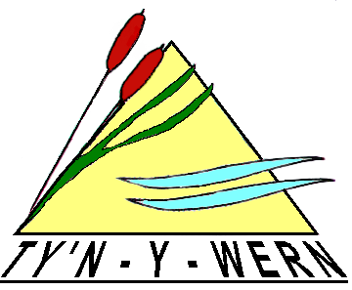
Headteacher: Mrs S Goodliffe
Heol yr Ysgol
Trethomas
Caerphilly
CF83 8FL
029 20852528 / 029 20852529
tywpa@caerphilly.gov.uk

Ty’n-Y-Wern Primary School - Ysgol Gynradd Ty’n-Y-Wern

Kind Hands and Clever Minds Make our School

TY’N Y WERN PRIMARY SCHOOL HOLIDAY FORM

The Governing Body discourages parents and guardians from removing their children from school for a family holiday during term time, as it recognises the vital importance of regular attendance to a child making good progress at school.
However, in some circumstances, where the situation is unavoidable, the Head teacher can authorise a maximum of 20 sessions (10days) absence in one academic year, for holidays. This is providing that the child’s attendance is above 95%. Holidays taken when absence is below this level or in excess of 20 sessions (10 days) will be marked as unauthorised absences.
If you must take you child on holiday during term time please complete and return this form to the school prior to the holiday.

Child’s name …………………………………… Class…………………………………..

Reason for removing your child from school during term time:

……………………………………………………………………………………………………………….

………………………………………………………………………………………………………………

Number of days holiday taken since September 1st ……………………………………..…....

Inclusive dates of holiday …………………………………………………………………………….

Number of school days that will be missed ……………………………………………………….

Signature of Parent/ Guardian ………………………..……………….. Date …………………..

Authorisation to be completed by school

I authorise …….. days absence. I do not authorise this absence due to

…….………………………………………………………………………………………………………..

Signed ……………………………… Position…………….……………… Date……………………..

Copy to parents/guardian; Copy to class teacher;

If you wish to discuss this decision please telephone the school office to make an appointment with the Headteacher

